**# 1) Load Titanic dataset**

titanic <- read.csv(file.choose(), stringsAsFactors = FALSE)

**# 2) Head and Tail**

head(titanic)

tail(titanic)

**Output :**

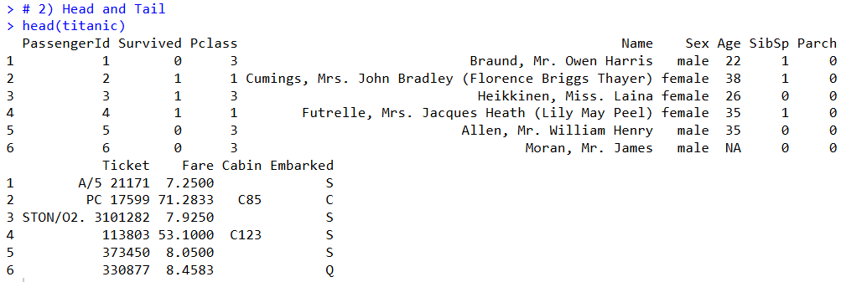

**# 3) Dimensions**

dim(titanic)

**Output :**

**# 4) Structure & Summary**

str(titanic)

summary(titanic)

**Output :**

**# 5) Class of all columns**

sapply(titanic, class)

**Output :**

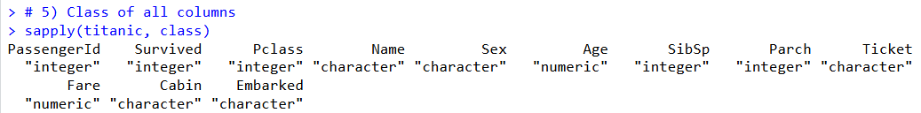

**# 6) Convert Survived & Sex to factor**

titanic$Survived <- factor(titanic$Survived, labels = c("Not Survived", "Survived"))

titanic$Sex <- factor(titanic$Sex)

**Output :**

**# 7) Convert Pclass, Embarked, SibSp to factor**

titanic$Pclass <- factor(titanic$Pclass)

titanic$Embarked <- factor(titanic$Embarked)

titanic$SibSp <- factor(titanic$SibSp)

**Output :**

**# 8) Check NA counts**

colSums(is.na(titanic))

**Output :**

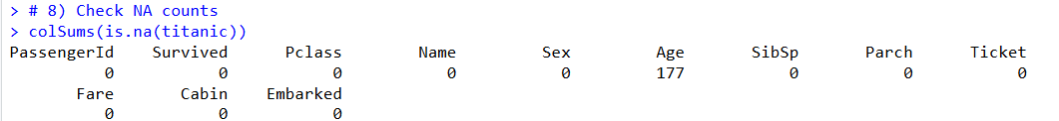

**# 9) Boxplot of Age**

boxplot(titanic$Age, main="Boxplot of Age", col="lightblue")

**Output :**

**# 10) Impute missing Age with median**

titanic$Age[is.na(titanic$Age)] <- median(titanic$Age, na.rm = TRUE)

sum(is.na(titanic$Age))

**Output :**



**# 11) Barplot - Pclass**

library(ggplot2)

ggplot(titanic, aes(x=Pclass, fill=Pclass)) +

geom_bar() +

labs(title="Univariate Analysis - Pclass")

**Output :**

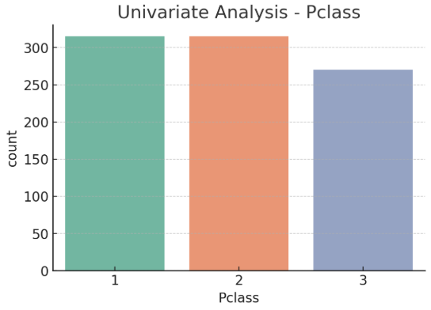

**# 12) Barplot - Survived**

ggplot(titanic, aes(x=Survived, fill=Survived)) +

geom_bar() +

labs(title="Univariate Analysis - Survived", y="No. of Passengers")

**Output** :

**# 13) Histogram of Age**

ggplot(titanic, aes(x=Age)) +

geom_histogram(binwidth=5, fill="steelblue", color="black") +

labs(title="Univariate Analysis - Age", x="Age")

**Output :**

**# 14) Barplot - Survived & Sex**

ggplot(titanic, aes(x=Survived, fill=Sex)) +

geom_bar(position="dodge") +

geom_text(stat="count", aes(label=..count..),

position=position_dodge(0.9), vjust=-0.3) +

labs(x="Survived", y="Count", title="Survival by Sex")

**Output** :

**# 15) Barplot - Survived & Pclass**

ggplot(titanic, aes(x=Survived, fill=Pclass)) +

geom_bar(position="dodge") +

geom_text(stat="count", aes(label=..count..),

position=position_dodge(0.9), vjust=-0.3) +

labs(x="Survived", y="Count", title="Survival by Pclass")

**Output :**

**# 16) Mean & Median of Age**

mean(titanic$Age, na.rm=TRUE)

median(titanic$Age, na.rm=TRUE)

**Output :**

**# 17) IQR and Range of Age**

IQR(titanic$Age, na.rm=TRUE)

range(titanic$Age, na.rm=TRUE)

**Output :**

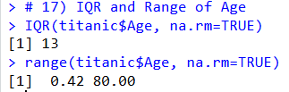

**# 18) Split dataset by Survived**

titanic_survived <- subset(titanic, Survived=="Survived")

titanic_notsurvived <- subset(titanic, Survived=="Not Survived")

**Output :**

**“Survived”**

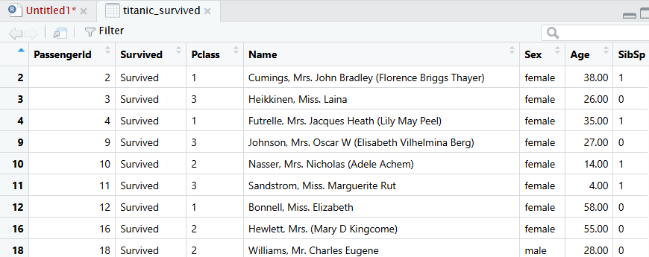

**“Not Survived”**

**# 19) Select Age & Survived (first 10 rows)**

library(dplyr)

titanic %>% select(Age, Survived) %>% head(10)

**Output :**

**# 20) Drop unnecessary columns**

library(dplyr)

cols_to_remove <- c("Name", "Fare", "Ticket", "PassengerId", "Cabin")

existing_cols <- intersect(names(titanic), cols_to_remove)

titanic <- titanic %>% select(-all_of(existing_cols))

names(titanic)

**Output :**

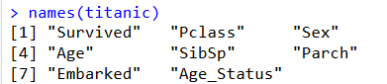

**# 21) Group_by Survived & Sex**

titanic %>% group_by(Survived, Sex) %>% summarise(count=n())

**Output :**

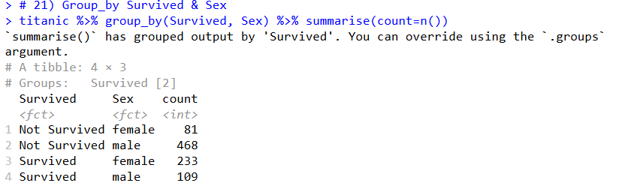

**# 22) Group_by Sex & Survived**

titanic %>% group_by(Sex, Survived) %>% summarise(count=n())

**Output :**

**# 23) Group_by Survived, summarise mean age**

titanic %>% group_by(Survived) %>% summarise(mean_age=mean(Age, na.rm=TRUE))

**Output :**

**# 24) Mutate new column Age_Status**

titanic <- titanic %>% mutate(Age_Status = ifelse(Age < 18, "Minor", "Major"))

head(titanic %>% select(Age, Age_Status))

**Output :**

**# 25) Filter only males & count Embarked station**

titanic %>% filter(Sex=="male") %>% group_by(Embarked) %>% summarise(count=n())

**Output :**

